HISTORY OF THE INTERNET

This goes down a huge rabbit hole but here is a quick summary of everything. Whoever made the internet is still unclear and open for discussion today.

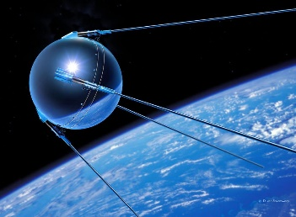**On October 4, 1957**, the Soviet Union(Russians) sent a satellite to outer space. This was called the Sputnik satellite and it was made to serve the purpose of sending radio transmitters back to the Soviets. This was unanticipated by the US government since they had a rather tight relationship. The US wanted to be ahead of the Soviets in terms of the latest technology thus launching Darpa which enabled the US research centers to connect.

However, there was a need to make computers connected and thus a man called JCR Lickliter had the idea of using the technology of landline phones and using computers instead of phones. This led to the development of ARPANET **(1960- 1970).**

By then, telecommunication was made between telegraphs using electrical pulses called morse code. This enabled communication between different parts of the state eliminating traditional mailing. This idea was morphed to accommodate computer technology thus protocols came to be in 1970. Transmission Control Protocol(TCP)and Internet Protocol were birthed at this time serving as the basis of modern Internet communication protocol.

In 1980, expansion and commercialization advanced as the internet expanded beyond military and academic roots with NSFNET and the adoption of TCP/IP as a standard. This decade also saw the emergence of Internet Service Providers(ISPs)

The World Wide Web was invented in **1989** by Tim Berners Lee and became publicly accessible in 1991. This marked the beginning of Graphical User Internet we are familiar with today.

The Dot Com Boom took place in the late **1990s** and saw rapid growth of internet companies and proliferation of websites leading to the burst of the dot-com bubble in the **early 2000s**. the burst of the dot com bubble led to the collapse of many internet companies but also paved the way for more sustainable business models and technologies.

**In the 2000s**, Social Media and the Web took the world by storm as platforms like Facebook, Twitter and YouTube as well as the concept of Web 2.0 which emphasized user-generated content and interactivity.

The mobile internet came to be in the 2010s. The proliferation of smartphones and mobile devices led to widespread adaptation of mobile internet usage, changing how people access the internet and web.The Internet of Things(IoT) has become increasingly prevalent, connecting everyday objects to the Internet. Additionally, developments in Artificial Intelligence, Virtual Reality, and Block chain technology continue to shape the future of the Internet.